The Work Number webManager Guide

The Work Number® from Equifax has an administrative tool known as webManager, to help you more easily manage your Organization's day to day needs of this service. All employer functions are accessible on webManager through your private personal account on The Work Number. WebManager access is added, changed or removed by Equifax via the request of your organization's Work Number administrator. If you need to make changes to webManager access for your organization just let your Account Manager or Workforce Solutions Support know.

Getting started with webManager
- Start by going to www.theworknumber.com
- Select “Log In” click "Manage Your Workforce"
- Select webManager Login from The Work Number Employer Login landing page
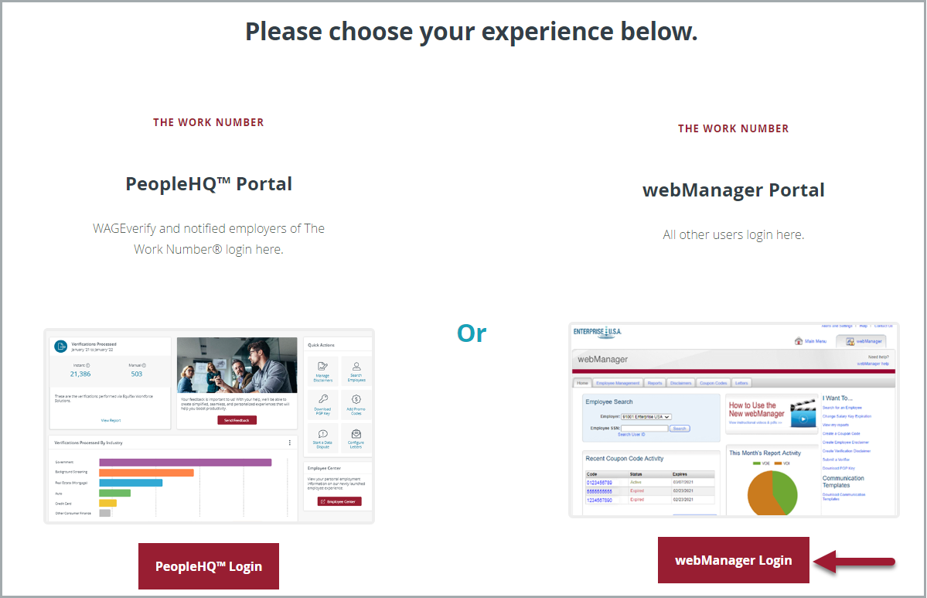

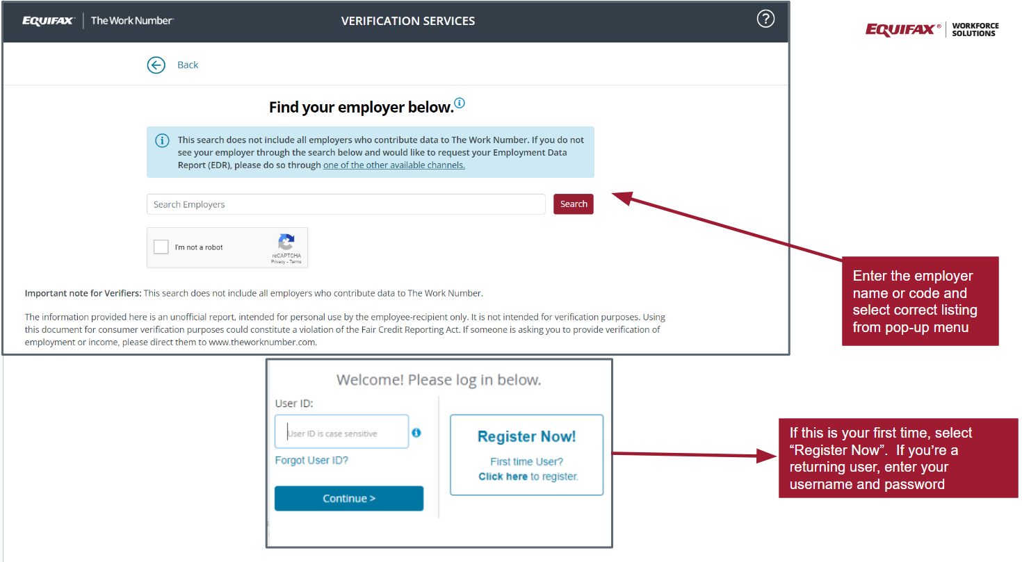
- Enter the Employer Name or Employer Code and select the correct listing from the pop-up menu
- If this is your first time – pick “Register Now”
- If a returning user – enter the username and password you set up
- The screen prompts will walk you through all the steps to help verify your identity and keep your account private while offering helpful messages if you have problems

Employer Reports
Get a clearer idea of the performance and ROI provided by The Work Number. Monthly activity reports are available in Adobe PDF format, allowing you to download them directly. Usage reports for the past 6 months are available. There are two types of reports available for webManager. Click on the Reports tab and then My Reports to access:
- Employer Reports - Monthly activity summary reports give details about transactions and usage of The Work Number. You can find these reports by searching by type.
- File Load Reports - A load report may be available for review once a file has loaded to The Work Number.
- To download a report, click the download icon beside the report.

In addition, real-time statistics for week-to-date, month-to-date, and past month activity are available for at-a-glance analysis.

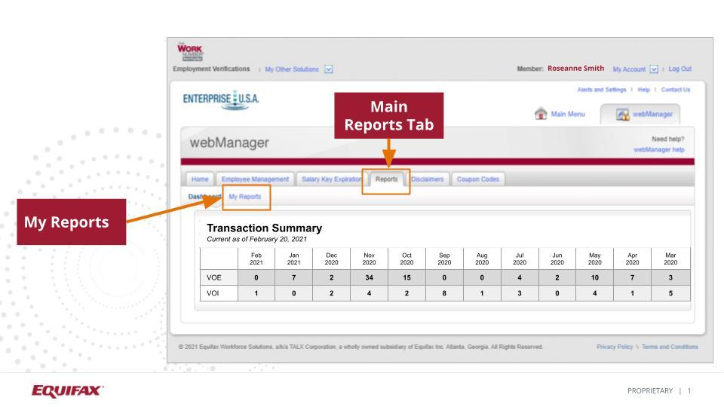

*Real-time statistics are not reconciled and may differ slightly from the final reconciled numbers reported in monthly activity reports. For additional information, contact your Account Manager.

Coupon Codes

You can provide a free trial coupon to a verifier who is unable or unwilling to pay for The Work Number verification service. This code will allow them to pull one verification of employment. Your organization is provided 10 coupon codes a month to use as needed. The Coupon code tab also allows a webManager to view coupon code activity for the organization overall.

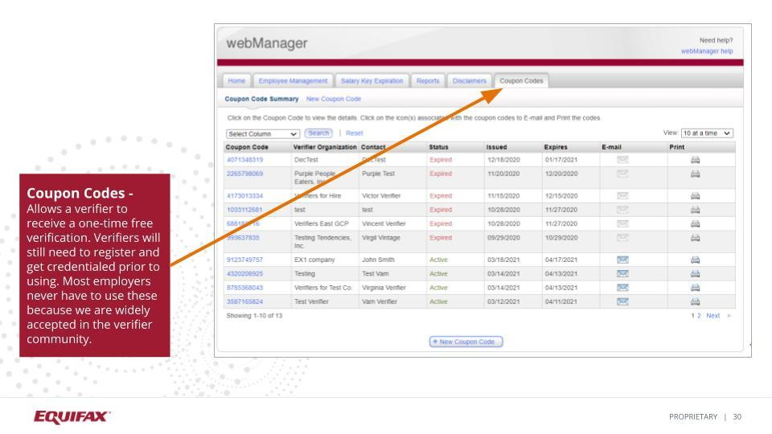

Division Codes

This feature gives you the ability to list any aliases company subsidiaries, or divisions which operate under your organization. This enables a verifier to more easily find employees within your organization.

*Configuring division codes is an advanced webManager feature. Please speak with your Account Manager for more information.

Employee Management

You have the ability to make a few adjustments to individual employee records.
- Change an employee’s employment status from active to inactive
- Block or unblock an employee’s data from being accessed (by that employee and verifiers)
- Notify The Work Number of an employee’s dispute of their information through the Employer Data Dispute Assistance feature
- Create a Salary Key on behalf of an employee* - Newly created Salary Keys expire after 90 days.
- See the information related to your company presented on an employee’s verification with Employment Verification Data

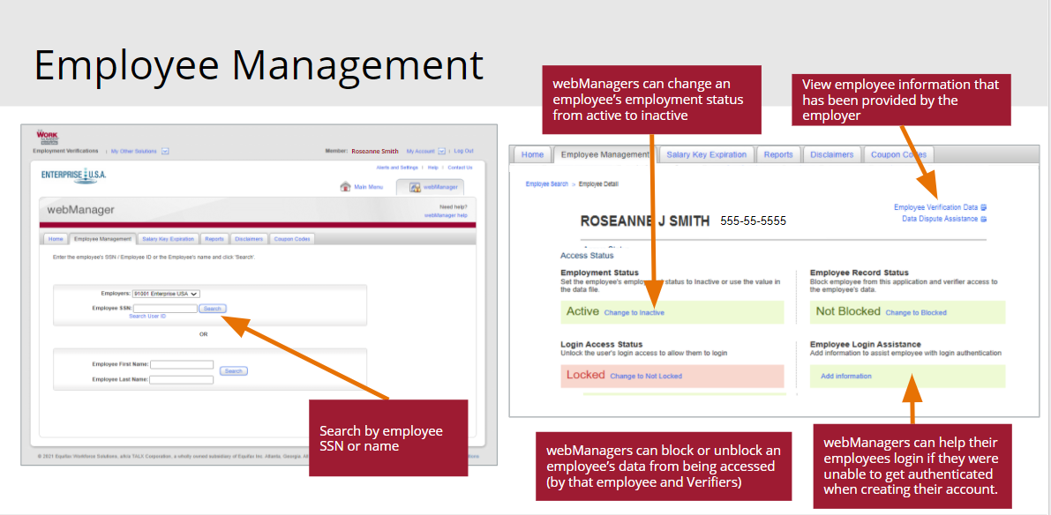

*Contact your Account Manager for the above configuration to be added. We have a call center available to your employees to help with these functions but a webManager has access to help if you choose to.

Additionally, on the Employee Management screen you can:
- Assist employees with their login through the Employee Login Assistance feature. This is utilized if an employee is unable to get authenticated the first time they try to register for an account on theworknumber.com. This feature will prompt the employer to furnish the employee phone number and email for a one-time passcode to get registered.
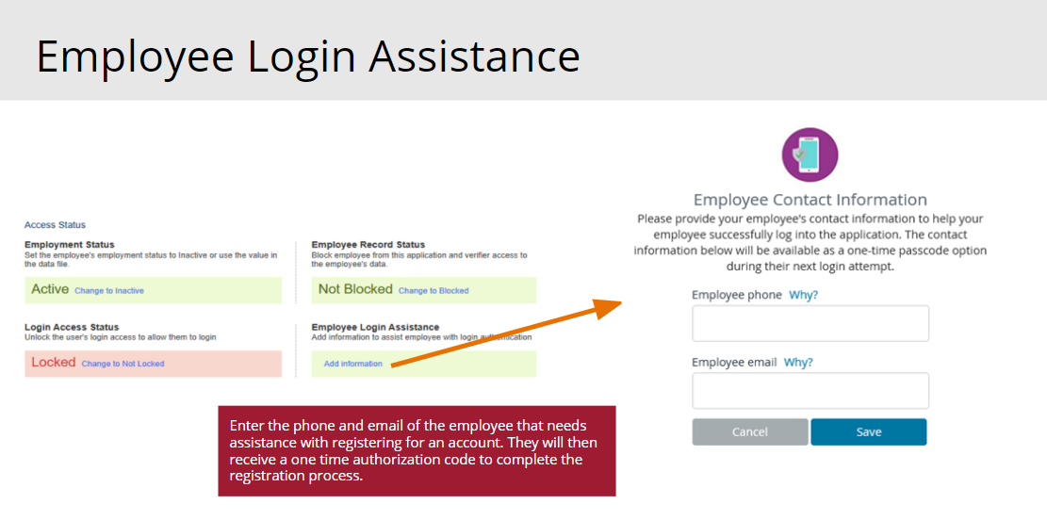

Communication Templates

Download and use our standard templates to rollout The Work Number information to your employees, verifiers and your internal staff.

The templates can be used to introduce The Work Number services to new employees or re-communicate to existing employees.

We suggest these be reviewed periodically by The Work Number administrators to ensure that all audiences are aware of The Work Number and its use by your organization. This helps ensure a more positive Work Number experience for everyone. (Link to Employer Communications - www.theworknumber.com/communications/direct/)

Submit Verifiers

Help stop the calls and letters for verification requests. You simply complete an online form with the verifier’s name and contact information and return to The Work Number. We will contact the verifier to let them know you are now using The Work Number.

Disclaimers

You have the ability to create or adjust employer disclaimers that appear on employee verifications. You can create specific disclaimers that will appear on the following types of verifications.

- Verification of Employment (VOE)
- Verification of Income (VOI)
- The Work Number Alert (TWA)
- Social Service Verifications (SSV)
- Disability / Worker’s Compensation (DWV)
- Employee Specific Disclaimer

*Configuring disclaimers is an advanced webManager feature. Please speak with your Account Manager for more information.
webManager Help

If you do not have your Account Manager’s email address readily available, you may find our technical support teams contact information here. They can get you the help you need or get you in contact with your Account Manager. You can also find release notes and other helpful tips in this knowledge base.

webManager User Roles

HR Functions - Includes the following functions (functions in bold cannot be removed from an HR User)
- Access to change verification disclaimers
- Block or Unblock an employee record
- Change employee status between Active and Inactive
- Create new employee disclaimer codes for use in data file exchange
- Create coupon codes
- Employee Search
- View activity reports
- View monthly summary and group reports:
- Create a Salary Key on behalf of an employee and ability to view Salary Keys (optional functions)
- View activity reports, monthly summary and group reports (optional functions)
- Unlock a user’s login access to The Work Number (optional functions)

Technical Functions - Includes the following functions
- Access to file load reports

See Own Employee (SOE) Functions - A SOE is not an official verification and cannot be used as one. This function simply allows the employer to view and confirm data that can be seen by a verifier and is accessed through the Employee Management tab on the Employee Verification Data link.
(This will be added to HR functions and/or Technical Functions, cannot be standalone) - Includes one or all of the following functions you can let us know what each user needs access:
- Ability to pull a Verification of Employment (VOE) on an employee
- Ability to pull a VOE and Verification of Income (VOI) on an employee
- Ability to pull a VOE, VOI, Social Service Verification, or other verifications

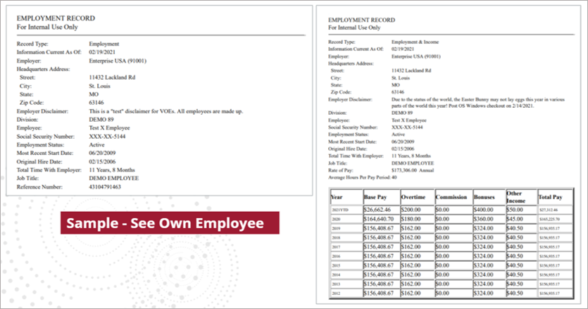

Have Questions?

While your Work Number Account Manager is your primary contact for Employment Verifications, The Work Number Solutions Support team is available to provide prompt attention to service-related requests for The Work Number. Members of the Solution Support team will respond to service-related technical requests and, if needed, will escalate and follow-up internally until your question is answered or the issue is resolved.

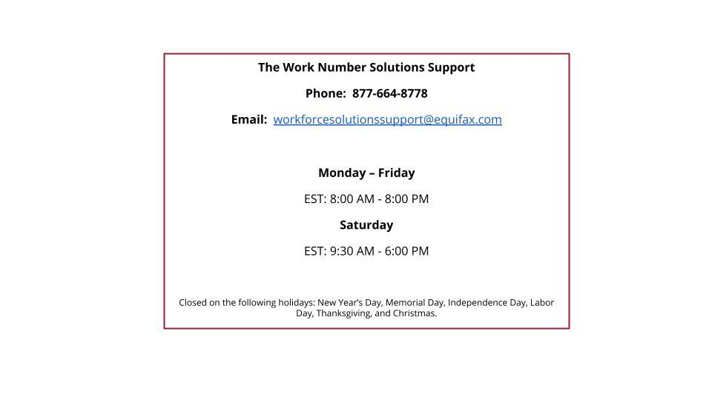
Copyright © 2022, Equifax Inc., Atlanta, Georgia. All rights reserved. Equifax is a registered trademark of Equifax Inc.
The Work Number® is a registered trademark of TALX Corporation, a wholly-owned subsidiary of Equifax Inc.

